**Lecture # 15:**

**Objective:**

* Database Connectivity (3 Layer)

o Record Selection

View Data From Database (simple)

# Database

use student

select * from StdInfo create table EmpInfo (

ID bigint,

Name nvarchar(20), NIC bigint

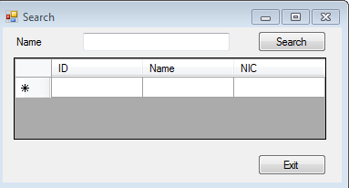)

# Presentation Layer

using System.Data.SqlClient;

namespace ViewDataSimple

{

public partial class Form1 : Form

{

public Form1()

{

InitializeComponent();

}

private void btnExit_Click(object sender, EventArgs e)

{

Application.Exit();

}

private void btnSearch_Click(object sender, EventArgs e)

{

try

{

String strCon = "Integrated Security=SSPI;Persist Security

Info=False;Initial Catalog=student";

SqlConnection sqlCon = new SqlConnection(strCon); if (sqlCon.State == ConnectionState.Closed)

{

sqlCon.Open();

}

String query = "select * from EmpInfo where Name like '%" + txtName.Text + "%'";

SqlCommand sqlCmd = new SqlCommand(query, sqlCon); SqlDataReader sdr = sqlCmd.ExecuteReader();

while (sdr.Read())

{

DGV.Rows.Add(sdr[0].ToString(), sdr[1].ToString(),

sdr[2].ToString());

}

sdr.Close(); sqlCon.Close();

}

catch (Exception ex)

{

MessageBox.Show("Message: " + ex);

}

}

}

}